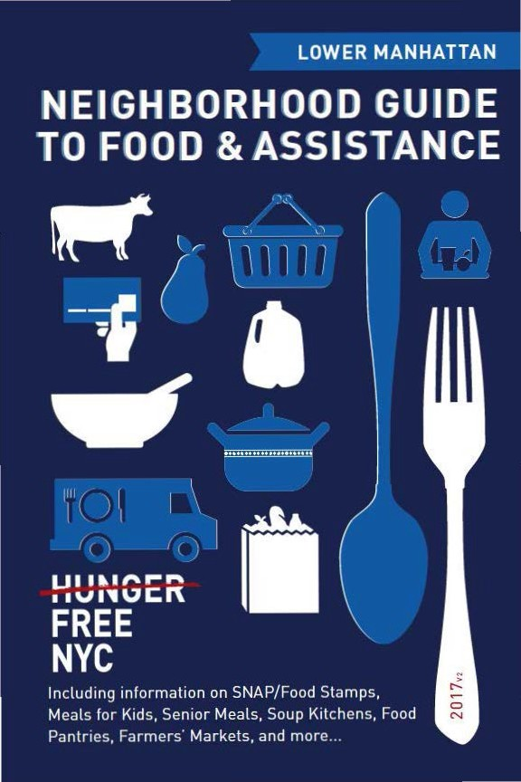

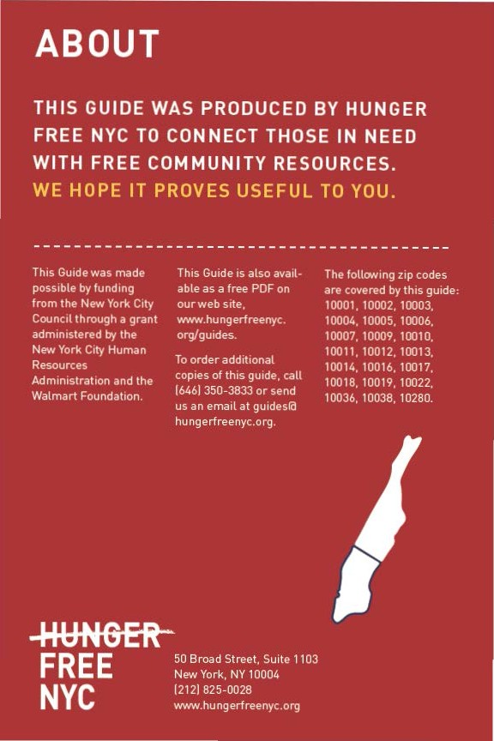

CON TEN TS

Food Stam ps/SNAP 4
6) Food fo r Kids 8
(I) Seni or Meals 1 1
0- Soup Kitchens & Food Pantries 1 2
e From the Fa rm 22
9 Em ployme nt & Tra in ing 25
Map of Locations 26
Other Assista nce 30
Emergency N um bers 31

Neighborhood Guide to Food and Assistance - Lower Manhattan Edition
 SNAP/
FOOD STAMPS
SNAP benefits, the new name for food stamps, can help put healthy food on the table by providing monthly assistance
to purchase food at authorized grocery stores and farmers' markets. Benef its are provided monthly th rough a plastic benef it card, similar to a de bit or credit card.



EBT
Stands for Electronic Benefit Transfer. It's the system the goverment uses to disburse benefits.

SNAP
Stands for
Supplemental Nutrition Assistance Program. "SNAP benefits" is the same thing as ..food stamps."

WHAT SHOULD I KNOW?

ID Employment does not interfere with getting SNAP.Even if you a re working, but earning lowwages, you may be eligible.
ID Average SNAP benefits a re over $100 per person per month, and $250 or more
for families. That mea ns that SNAP benef its for the average family receiving them totals more than $3,000 worth of food support
each year.
ID Farmers' markets often accept SNAP benefits, so you ca n purchase fresh produce and food-producing seeds and plants using your benefits. For a complete list of farmers' markets that accept them , see page 22.

IINeighborhood Guide to Food and Assistance ·Lower Manhattan Edition

AM I ELIGIBLE?


Eligibilit y is based on household size, income, expenses and other factors. Households have to meet income tests to receive benefits, but households that have members w ho are disabled or elderly (60 or older), or have out-of-pocket expenses for
.
child care or dependant ca re, ca n have higher incomes a nd still be eligible.

NUMBER OF PEOPLE
A
MONTHLY INCOME LIMIT
1
IN HOUSEHOLO | (PRE-TAXES] |  | SNAP BENEFITS
1 | $1 ,307 |  | $192
2 | $1 ,760 |  | $352
3 | $2,213 |  | $504
4 | $2,665 |  | $640

MAX.MONTHLY
2

Each additional household member
+$453
(approximately)
+ $144
(approximately)

11n effect
10/1/16 - 9/30/17.

21n effect
10/1/16 - 9/30/17.

If you meet the above income qualifications, it doesn't matter how much money you may or may not have in countable resources. In other words, you can save money for education , a home purchase, or retirement a nd still receive SNAP benefits.

Neighborhood Guide to Food and Assistance - Lower Manhattan Edition II

IMMIGRANT ELIGIBILITY

Legal immigrants can often receive SNAP benefits if they:
- have lived in the country for 5 years or more; or
- are children (under age 18).
Ineligible immigrant parents can still receive benefits for their children even if a parent does not qualify.
Certain non-citizens, such as those admitted for humanitarian reasons, may also be able to receive benefits.
Immigration status is not negatively affected if you apply for or receive SNAP benefits.

HOW TO APPLY

Apply at Select Community Organizations
1

Call either of the below numbers to see if you may be eligible for benefits. If so, you’ll be offered an appointment at an agency in your community, where you’ll receive help in submitting your application electronically.
Hunger Free NYC
646 355 1475 & 646 350 1104

Neighborhood Guide to Food and Assistance - Lower Manhattan edition
6

ACCESSNYC
2
SNAP/FOOD STAMPS

Apply online at: www.nyc.gov/accessnyc

Visit Your Local HRA Office
3

Apply at a SNAP office near you:

1 waverly SnaP Center
12 W. 14 St., 4th Floor, 10011
718 722 8013
Mon–Fri 8:30am-6pm, Sat 9am-5pm

You can also call 718 557 1399 to find a SNAP office near you and for information about qualifications, guidelines, and applications.

Neighborhood Guide to Food and Assistance - Lower Manhattan edition
7
I)FOOD FOR KIDS
WOMEN , INFANTS & CHILDREN

W IC is the Women, Infants & Chi dren Program.

QUICK FACTS
m WIC is for low-income pregnant women, breast -feeding women, and women with child ren under the age of five.
m You ca n work and still get WIC.
m You can continue to get cash assistance or SNAP benefits/food stamps while receiving WIC.
m You can get WIC even if you are undocumented or not a citizen.

HOW TO A PPLY
To find the WIC office nearest you call 800 522 5006, call 866 3-H UNG RY or visit these local WIC offices.
- Mt. Sinai Health System WIC Program- Roosevelt 515 W.59 St., 2nd Floor. 10019
212 523 6539
Mon ,Wed, Thu 9am-5pm; Tue 9am-7pm; Fri 9am-4pm
- Bellevue - East Side WIC
462 1 Ave., Ground Floor, 10016
212 562 6124
Mon, Wed, Fri 8:30am-5pm; Tue, Thu 8:30am-6pm. 2nd Sat 8am- 3:30pm by appt. only
- Bellevue - Chinatown WIC 221 Canal Street, 10013 212 274 9655
Mon 8:45am-5:45pm, Tue-Fri 8:45am-4:15pm, 2nd Sun 8:30am- 3:30pm by appt. only
IINeighborhood Guide to Food and Assistance - Lower Manhattan Edition
- Gouverneur hospital Chinatown wIC
125 Walker St., 10013
FOOD FOR KIDS
212 226 8375
Mon-wed 9am-5pm, Sat by appt. only
- william F. ryan - nena Community health Center wIC
279 E 3rd Street, 10009
212 477 8500
Mon 9am-7pm, tue-Fri 9am-5pm
- Gouverneur hospital wIC 227 Madison Street, 10002 212 238 7145
Mon-Fri 8am-5pm, Sat by appt. only
- new York Presbyterian Lower Manhattan wIC - Chinatown
244 Grand St, 4th Fl., 10002
646 588 2646
Mon-Fri 8am-4pm
- new York Presbyterian Lower Manhattan wIC
69 Gold St., Lobby Level, 10038
212 312 5831
Mon-Fri 8am-5pm

Neighborhood Guide to Food and Assistance - Lower Manhattan edition
9
SChooL & SUMMer MeaLS

SFSP is the Summer Food Service Program, also known as Summer Meals.
QUICK FaCtS
During school, free breakfasts are available to all children regardless of income, with no paperwork required.
Many public school students are also eligible for free or reduced price lunch. An application may be required.
Eligibility for school meals is not impacted by immigration status.
In June, July and August, lunch and breakfast are served for free to all children under 19 at many public schools, houses of worship, recreation centers, and community centers - no application or registration required.
Visit www.schoolfoodnyc.org for more information about school breakfast, school lunch, and summer meals. For nearby summer meals sites, text FOOD to 877-877, call 311, or call the National Hunger Hotline at 866 3-HUNGRY.

Neighborhood Guide to Food and Assistance - Lower Manhattan edition
10

eSENIOR MEALS
MEALS AT SENIOR CENTERS
Senior centers often serve meals for older people. Some centers offer free meals, oth ers ask for a small contribution !from fifty cents up to a few dollars!. This contribution may be voluntary or required. Senior cen ters and other sites with food for seniors are marked with • in the Soup Kitchens and Food Pantries section.
FIND YOUR LOCAL SENIOR CENTER
Call 311 and be prepared to provide your ZIP code to the operator.

MEALS- ON- WHEELS PROGRAM
If you are homebound and over the age of 60, you can receive home-delivered meals up to 7 days a week. Household income does not
affect eligibility.
HOW TO APPLY
To request meals-on-wheels service , call yourlocal case management agency.
To find the appropriate agency, contac t the Citymeals-on-Wheels' Program Department at 212 687 1234 or the National Hunger Hotline at 866 3-HUNGRY.
Neighborhood Guide to Food and Assistance - Lower Manhattan Edition

SOUP KITCHENS OFOOD PANTR IES


Ag encies listed as soup kitchens provide prepared meals during
their listed serving times, w hile agencies listed as food pa nt ries provide bags of food to be prepared at home.
While we try to keep this list as accurate and up-to-date as possible, we recommend calling the agency before going to confirm their schedule.Some agencies require a referral, ID, or proof of address. To confirm, contact the agency directly. call the NYC Emergency
Food line at 866 888 8n7 or call the National Hunger Hotline at 866
3HUNGRY.Agencies marked with are senior centers and/or provide food spec1f1cally for seniors.
MIDTOWN
10019. 10022. 10036, 10018.10001. 10010. 10016.10017
1O Church of St. Paul the Apostle loaves and Fishes 405 West 59th Street. 10019
212 265 3495
Soup Kitchen:Tue, Thu 11:30am-12:15pm Food Pantry:Tue, Thu 11:30am-12:15pm
11 St.Paul's House
335 W.Slst St., 10019
212 265 5433
Soup Kitchen:Mon, Wed, Fri 7:15am-8:30am Food Pantry:Tue lOam-1l am
Must live between 10th St.and 89th St. on the West Side. ID and proof of residence required for pantry.

IINeighborhood Guide to Food andAssistance - Low•r Manhallan Edition
- encore Senior Center 239 W 49th Street, 10019 212 581 2910
PANTRIES & KITCHENS
Soup Kitchen: Mon-Fri 9am-10am, 11am-1pm For seniors (60+) only.
- Grand Central Food Program - 51st & Broadway
SW corner of 51st St. and Broadway, 10019 212 776 2000
Mobile Soup Kitchen: everyday 7:15pm Come on time - distribution is mobile.
- Grand Central Food Program - SonY Building 55th St. between Madison and 5th Ave., 10022 212 776 2000
Mobile Soup Kitchen: everyday 9:15pm Come on time - distribution is mobile.
- Central Synagogue Breakfast Program
123 E. 55th St, 10022
212 838 5122
Soup Kitchen: thu, Fri 6am-7:30am Hot meal with bagged lunch to go.
- St. Peter's Lutheran Church
619 Lexington Ave. at 54th St, 10022 212 935 2200
Soup Kitchen: tue 7am-8:30am
Doors open at 7am, service starts at 7:15am.
- Momentum Project at St. Peter's Lutheran Church
619 Lexington Ave. at 54th St., 10022 212 691 8100
Soup Kitchen: tue 4pm-6:30pm Clients must complete intake at 3pm.
- Grand Central Food Program (Coalition for the homeless)
108 E. 51st St, 10022
212 776 2000
Mobile Soup Kitchen: everyday 5:30pm-7pm At St. Bartholomew's Church

Neighborhood Guide to Food and Assistance - Lower Manhattan edition
13
- Crossroads Community Services at St. Bartholomew's Church
108 E. 51st Street, 10022
212 378 0231
Soup Kitchen: Sun, Mon, wed 7am-8:30am; Sat 9:30am-11am
Food Pantry: thu 10am-2pm
For pantry can come once/month, appointment required, call to make appointment 212-378-0234
- St. Luke's Lutheran Church
308 W. 46th St., 10036
212 246 3540
Soup Kitchen: tue, thu 1pm-2pm
- the relief Bus - Port authority
9th Ave. between 40th and 41st, 10036 800 736 2773
Soup Kitchen: Sat 7:30pm-10:30pm
- Crossroads Food Pantry 329 W. 42nd St, 10036 212 246 4732
Food Pantry: every other Sat 11am-1pm Proof of residence and income required.
- the Dwelling Place of n.Y., Inc.
409 W. 40th St., 10018
212 564 7887
Soup Kitchen: wed 5:30pm-6:30pm For women age 30+ only.
- rauschenbusch Metro Ministries - Metro Baptist Church
410 W. 40th St, 10018
212 594 4464
Food Pantry: Sat 11am-11:30am (no pantry 5th Sat)
One visit per month. ID and proof of address for all household members required.

Neighborhood Guide to Food and Assistance - Lower Manhattan edition
14
- Sylvia rivera Food Pantry
PANTRIES & KITCHENS
446 W. 36th St., 10018
212 629 7440
Food Pantry: tue-Fri 2pm-3pm (snack bags); thu 9am-10am (groceries - for all); tue-Fri 2pm-3pm (groceries - for people living with AIDS); tue-Fri 10am-3pm emergency pantry Bring your own bag for pantry.
- Grand Central Food Program - Port authority 40th St., between Dyer and 10th Ave., 10018 212 776 2000
Mobile Soup Kitchen: everyday 7:30pm Come on time - distribution is mobile.
- Gay Men's health Crisis 446 West 33 Street, 10001 212 367 1000
Food Pantry: tue, wed, Fri 1pm-4pm; thu 11am-2pm
After first visit, must become a member - call 212 367 1057 to make an appt.
- aIDS Service Center nYC 64 W. 35th St., 3rd Fl., 10001 212 645 0875
Food Pantry: Fri 10am-3pm ID required.
- Grand Central Food Program - Penn Station
West side 8th Ave. at 33rd St., 10001 212 776 2000
Mobile Soup Kitchen: everyday 9pm Come on time - distribution is mobile.
- the relief Bus - Chelsea Park
28th St., between 9th & 10th Ave., 10001 800 736 2773
Soup Kitchen: wed, Fri 10am-2pm

Neighborhood Guide to Food and Assistance - Lower Manhattan edition
15
- holy apostles Soup Kitchen
296 9th Ave., 10001
212 924 0167
Soup Kitchen: Mon-Fri 10:30am-12:30pm
Social Services Office open during Soup Kitchen hours with mail and phone facilities, free hair cut referrals, toiletries, and counselors.
- St. Francis of assisi 135 W. 31st St., 10001 212 736 8500
Soup Kitchen: everyday 7am-7:30am (Sandwiches and coffee, line starts at around 6:30am)
Food pantry: Fri, Sat 9am
Must register for pantry by calling 212-471-4246.
- Grand Central Food Program - Madison Square Park
5th Ave. and 27th St., 10001 212 776 2000
Mobile Soup Kitchen: everyday 8:35pm Come on time - distribution is mobile.
- new alternatives for Children
37 West 26th Street, 6th Floor, 10010 212 994 7919
Food Pantry: Mon, tue 2pm-5pm
- Grand Central Food Program - 35th & FDr
35th Street under FDR Drive, 10016 212 776 2000
Mobile Soup Kitchen: everyday 7:15pm Come on time - distribution is mobile.
CheLSea, weSt VILLaGe
10011-10014
- St. Peter's episcopal Church
346 W. 20th St., 10011
212 929 2390
Food Pantry: Sat 10:30am-11:30am Referrals requested when available.

Neighborhood Guide to Food and Assistance - Lower Manhattan edition
16
- hope for our neighbors in need at Church of the Village
PANTRIES & KITCHENS
201 W. 13 St., 10011
212 243 5470
Soup Kitchen: tue 1pm-2:30pm, Sat 12pm-1:30pm Food Pantry: tue 1pm-2:30pm, Sat 12pm-1:30pm Doors open 30 minutes before food service begins.
- Salvation army new York temple
132 W. 14th St., 10011
212 337 7469
Soup Kitchen: Mon-thu 12pm-1pm
Food Pantry: Mon-Fri 9:30am-11am, 1:30pm-3pm.
Food pantry requires photo ID and proof of address in 10002- 10007, 10009-10014, 10038, 10041, 10047, or 10048 at first visit.
Please call 212-337-7469 for an appt.
- Xavier Mission at the Church of St. Francis Xavier
55 W 15th St., 10011
212 627 2100
Soup Kitchen: Sun 12:45pm-3pm
Seniors and disabled line up on 15 St., all others on 16th St. (elevator for those unable to navigate stairs on 15th St)
Food Pantry: 2nd Sat 10am-11:30am; Pantry is client choice; open only to residents of 10001-10003, 10009-10014, 10016. ID and proof of address for all adult household members required for pantry.
- Church of the ascension 12 West 11th St., 10011 212 254 8620
Food Pantry: 2nd, 4th Sat 8:30am
Arrive early to get in line. First come first served. Often 200+ people in line. Line up on north side of West 11th Street starting at 5th Ave.
- Church of St. Joseph in Greenwich Village
371 6th Ave, 10014
212 741 1274
Soup Kitchen: Sat 1:30pm-3pm

Neighborhood Guide to Food and Assistance - Lower Manhattan edition
17
- Judson Memorial Church
55 Washington Square South, 10012
212 477 0351
Soup Kitchen: 1st wed 7:15pm
Potluck meal, doors open 7pm, meal followed by a performance.
- hebrew Union College-Jewish Institute of religion
1 West 4th St., 10012
212 674 5300
Soup Kitchen: Mon 5pm-6pm
Entrance on Mercer Street. During the school year, warm balanced meals, clothing, toiletries, music, and free legal advice from NYU law students inside. In summer months, service is 5pm-5:30pm outside.
- new York City rescue Mission
90 Lafayette Street, 10013
212 226 6214
Soup Kitchen: everyday 6:30am-7am, 5pm-6:30pm
Food Pantry: every other Mon, wed, Fri 1:30pm-2:30pm
ID required for pantry. Medical and Social Worker (complete at front desk) Fri 7am-11am, SNAP and Medicaid Enrollment Mon, Wed 3pm-5:30pm; Fri 2:15pm-4pm, New women's shelter intake every day 3pm-4pm, New men's shelter intake every day 4pm- 5:30pm
- Grand Central Food Program - Lafayette & Leonard
Lafayette St. and Leonard St., 10013 212 776 2000
Mobile Soup Kitchen: everyday 7:45pm Come on time - distribution is mobile.
eaSt VILLaGe, Lower eaSt SIDe, ChInatown
10003, 10009, 10002
- Village temple Soup Kitchen 33 East 12th Street, 10003 212 674 2340
Soup Kitchen: Sat 2:30pm-4pm

Neighborhood Guide to Food and Assistance - Lower Manhattan edition
18
- St. George's Common table 209 East 16th Street, 10003 646 723 4178
PANTRIES & KITCHENS
Soup Kitchen: thu 12pm-12:45pm Doors open at 11:30am.
- the hetrick-Martin Institute 2 Astor Pl., 3rd Fl., 10003 212 674 2400
Soup Kitchen: Mon-Fri 6pm-7:15pm; Sat 1pm-2pm, 4pm-5pm For youth only (13-24). Must complete intake to become client (Mon-Fri 5:30pm, Sat 12pm) with photo ID, proof of age. Provide academic enrichment, arts and culture, health and wellness, counseling, job readiness, and homeless services. www.hmi.org
- Momentum Project at Middle Collegiate Church
50 E. 7th St., 10003
212 477 0666
Soup Kitchen: Mon 11am-1pm, 4pm-6:30pm Intake at 3pm for evening clients.
- St. Joseph house/Catholic worker
36 East 1st St., 10003
212 254 1640
Soup Kitchen: tue-Fri 10am-11:30am
Men only, Clothing rummage room Mon-Fri 2:30pm-4pm
- Father's heart Ministries
543-545 East 11th Street, 10009
212 375 1765
Soup Kitchen: tue 6pm-7pm (only for KidZone attendees), Sat
10am-11am (except 1st Sat)
Food Pantry: tue 6pm-6:30pm (only for KidZone attendees), Sat
10am-11am (except 1st Sat)
SNAP (food stamps) pre-screening available. Free GED and ESL classes Sat 10am-11:30am, Tue 6pm-7:30pm; legal aid desk 2nd Sat.

Neighborhood Guide to Food and Assistance - Lower Manhattan edition
19
- Chilis on wheels
Tompkins Square Park (E 9th St and Ave A), 10009 303 618 0528
Soup Kitchen: Sat 1pm-3pm
Clothing distribution once/month, care package distribution seasonally.
- trinity Services and Food for the homeless
602 E 9th St., 10009
212 228 5254
Soup Kitchen: Mon-Fri 11am-12pm
Food Pantry: Mon-Fri 12:30pm-1:30pm
ID for all household members required for pantry. Pantry is client choice, may be received once a calendar month. www. safhnyc.org
- University Community Social Services
137 East 2nd St., 10009
347 850 2230
Soup Kitchen: Sat 8am-2:30pm
Food Pantry: Sat 1pm-2:30pm
- the Bowery Mission 227 Bowery, 10002 212 674 3456
Soup Kitchen: everyday 8am-9am, 1pm-2pm, 6pm-7pm
Food Pantry: Mon-Fri 9am-11am
Other social services provided, call or visit for details.
- Grand Central Food Program - Bowery Mission
Bowery Mission-Bowery between Stanton & Rivington, 10002 212 776 2000
Mobile Soup Kitchen: everyday 8:20PM Come on time - distribution is mobile.
- Grand Coalition of Seniors-Grand Street Settlement
80 Pitt St, 10002
646 201 4251
Soup Kitchen: Mon-Fri 9am-10 am, 12pm-1pm Seniors (60+) only, ID required.

Neighborhood Guide to Food and Assistance - Lower Manhattan edition
20
- Dewitt reformed Church Food Pantry
PANTRIES & KITCHENS
280 Rivington St., 10002
212 674 3341
Food Pantry: Mon, thu 10am-12pm
- UJC of the east Side
7 Willett St, 10002
Soup Kitchen: Mon-Fri 12pm-1pm, doors open 11:30am.
Food Pantry: Mon-Fri 9:30am-2pm For seniors (60+) only. ID required.
- Primitive Christian Church 207 East Broadway, 10002 212 673 7868
Food Pantry: 1st thu 8am-finish ID required.
- Grand Central Food Program - allen St.
25 Allen St. (Lower East Side Harm Reduction), 10002 212 776 2000
Mobile Soup Kitchen: everyday 7:30pm Come on time - distribution is mobile.
- Cabrini Immigrant Services of nYC
139 Henry St., 10002
Food Pantry: tue 9:30am-12:30pm
Bring photo ID. Emergency pantry walk-ins as necessary M-F 9am-5pm.
Downtown
10271, 10004-10007
- trinity Church Brown Bag
75 Broadway, 10271
212 602 0800
Soup Kitchen: Sun 2pm, Mon-Sat 12:45pm-1:15pm (Fri and Sat at St. Pauls Chapel 209 Broadway)
Brown bag meal.
- Grand Central Food Program - Staten Island Ferry terminal
Staten Island Ferry, 10004 212 776 2000
Mobile Soup Kitchen: everyday 8:00pm Come on time - distribution is mobile.

Neighborhood Guide to Food and Assistance - Lower Manhattan edition
21
eFROM THE FAR M
New Yorkers can access foods straight from the farm in two ways: farmers' markets and community su pported ag riculture programs or CSAs.

FARMERS' MAR KETS

All farmers' markets listed accept EBT/SNAP (food stamps).

MIDTOWN
10019, 10022, 10036, 10018. 10001, 10010, 10016, 10017
- 57th Street Greenmarket
W. 57th St, & N inth Ave. !Balsley Park). 10019 Wed, Sat 8am-5pm, May 17-Dec 23
- Dag Hammarskjold Plaza Greenmarket
E. 47th St. & Second Ave , 10017
Wed 8am-4pm, year round. Closed Sept 20.
- Hudson Yards Down to Earth Farmers' Market Hudson Blvd. East at 34th St., 10001
Thu 11am-6pm.Jun-Dec
CHELSEA ,WEST VILLAGE
10011-10014
- Chelsea Down to Earth Farmers' Market 23rd St. at 9th Ave.. 10011
Sat 9a m-4pm , May-Dec
- PS 11 Farm Market
W. 21 St. between 8Ave.& 9 Ave., 10011 Wed 8am-10am. Jun-Nov
- Abingdon Square Greenmarket W. 12 St. & 8th Ave., 10014
Sat 8a m-2pm . year round
IINeighborhood Guide to Food and Assistance - Lower Manhattan Edition
eaSt VILLaGe, Lower eaSt SIDe, ChInatown
10003, 10009, 10002
FROM THE FARM
- Union Square Greenmarket
E. 17 St. & Broadway, 10003, 10003
Mon, wed, Fri, Sat 8am-6pm, year round. Closed Fri after Thanksgiving.
- St. Mark's Church Greenmarket
E 10 St. & 2 Ave., 10003
tue 8am-6pm Jun 6-Nov 21. Closed Independence Day.
- Stuyvesant town Greenmarket
14th St. Loop & Ave. A (in the Oval), 10009, 10009
Sun 9:30am-4pm, May 14-Dec 19
- tompkins Square Greenmarket E. 7 St. & Ave. A, 10009, 10009 Sun 9am-6pm, year round.
Downtown
10271, 10004-10007
- tribeca Greenmarket
Greenwich St. & Chambers St., 10007
wed 8am-3pm, Mar 1-Dec 21; Sat 8am-3pm, year round.
- City hall Park Greenmarket
Broadway & Chambers St., 10007
tue, Fri 8am-4pm, Mar 3-Dec 22. Closed Independence Day.
- Bowling Green Greenmarket
Broadway & Battery Pl., 10004
tue, thu 8am-5pm, year round. Closed Independence Day and Thanksgiving.
- Staten Island Ferry/whitehall Greenmarket
4 South St. (inside terminal), 10004
tue, Fri 8am-7pm, year round. Closed Independence Day and Fri after Thanksgiving.
- water Street Greenmarket
Water Street and Coenties Slip, 10004
thu 8am-6pm, Jun 1-Nov 16

Neighborhood Guide to Food and Assistance - Lower Manhattan edition
23
CSa ProGraMS

CSA members purchase "shares" in an entire season of high quality, fresh produce grown by local farmers. Members usually pay for their shares in advance, but some CSAs adjust payment to income, ac- cept SNAP benefits, and allow some members to pay week to week. Members typically pick up boxes of produce from a set location every week though some CSAs have half-shares available for pick up every other week.
Note that sign up is generally March to May, with the first pickup in June or July and the last one in late October or early November. As a rule, late sign up is not permitted. Some CSAs also have limited winter shares.
Corbin hill
Multiple pickup locations. Allows signups Tuesday/Wednesday before first pickup. Permits weekly payment and payment via SNAP. Weekly in summer, every other week in winter. Reduced price shares available. Visit Corbin Hill's website, call, or email to find a CSA program near you and sign up.
Contact: info@corbinhillfarm.com, 646 254 2250
web: www.corbinhillfoodproject.org/new-farm-share/

Just Food
Multiple pickup locations. Sign up deadlines and SNAP acceptance vary. Winter shares available from some CSAs. Visit Just Food's website, call, or email to find a CSA program near you. Contact the CSA directly to sign up.
Contact: info@justfood.org, 212 645 9880
web: www.justfood.org/csaloc

Neighborhood Guide to Food and Assistance - Lower Manhattan edition
24

r-\ JOB TRAINING &
RESOURCES

Certain individuals may be required to be employed, seeking employment and I or enrolled in a training program in order to receive SNAP benefits.

EMPLOYMENT & TR AINING

Visit the following sites to fi nd out more about training and education programs across the city:

www1.nyc.gov/html/sbs/wf1/html/develop/develop. shtml www 1.nyc.gov/site/hra/help/types-tra ining-ed ucation. page

Neighborhood Guide to Food and Assistance - Lower Manhattan Edition II

vves1 "om 1ree1 9'
West 37th Street
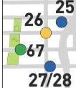

ti)
2
West 36th Street
West 35th Street «>
West 34tl eet

9
West 31st Slreel
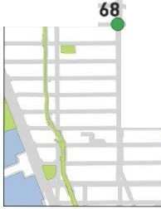
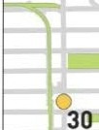
West 30th Street

West 32nd Street
()
32

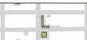

- Food Pantry

- Fa rmers ' Ma rket


East 33rd Street East 31st Street
East 30th Street

West 29th Street West 28th Street f


)> :::> J4
West 26th Street i.. iWest 25th Street
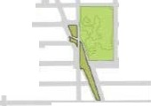

West 23rd Street
West 22nd Street
East 29th Street
East 28thStreet

033 East 27th Street
East 26th Street
East 25th Street
East 24th Street
East23rd Street East 22nd Street

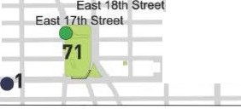
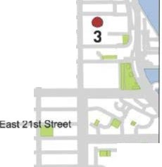
69•
•
36
West 21st Street

West 19th Street West 18th Street
West 17th Street
West 16th Street 39
West 15th Street ()
37() <t 39

East 20th Street
East 19th Street

0
''

"' 73
a. •
East 16th Street
2 East 15th Street
m East 14th Stree East 13th Str et

II
•2


Central Park SOuth
10 West 58lh Street
r East 59th Street
El!st 58th Street

West 561h street JS
West 57th Street
East 57th Street .
15 C East 56th Street o

West 55th Street West 54th Street
West 53rd Street West 5200 Street West S1st Stroot West 50th Street West 49th Street West 48th Street
0 16117 East 55th Street
East 53rd Street East 52nd Street


E
a g East 51st Street
i
18/19 East 50th Street
5i East 49th Street _.
East 481h Street
East 47th Street 66

West 46th S eel West 45th Street
21 0
•22

West 44lh Street
East 46th Street • East 45th Street
East 44th Street 0
East43rd Street
....

23
West 40th Street

West 39th Street
•SNAP/Food Stamp Office 42nd Stre,it

•WIC Office


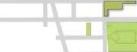

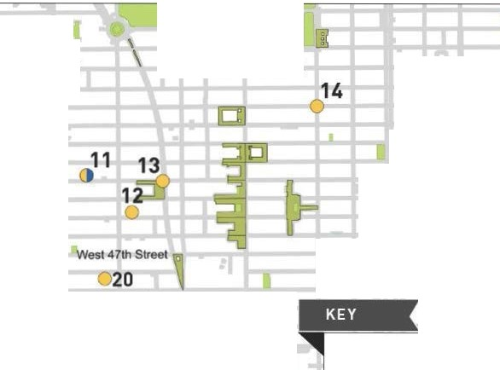
24 "' 0 M" ' 0 -,l
Soup Kitchen

Franl\lin Street

Worth Street
;y
45 \
0

Thomas Street <1<>1,>.. 0
Duane Street
Reade Street <?'11
- Chambers Street. o J
75Warren Street 'l6
Murray Street
r

Park Place .S,o'U
'f'I Barclay Street liesey Street

Street

Fulton Street
Dey Street q;
Cortlandt Street IQ)
liberty Street j{J
063'12:1

Carlisle Street

\!l
Ota •



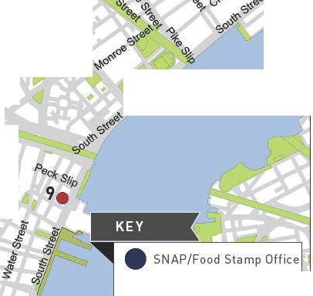
Rector Streel z Wa11 Street
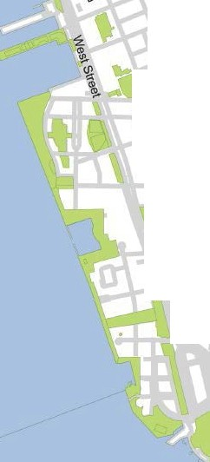

79 Slip
•
e>
77
78
64
W IC Office
Soup Kitchen

- Food Pa ntry

- Farmers' Market

t 12th Street West 11th Stre1t
40
a: 46
.
.

72 East 11th Street
52

East 11Street
n

West 8th Street
!!!
c
:::> Gi
e
en
J"'

043
0
Saint Mark's Place e74
East 1Ot Street

:i 53
OJ East 7th Street-
st 6th Street East 5th Street

0 "'
42

Great Jones Street Bond Street
East 4th Street
4 EasJ3r.d Street ·
(t)> East 2nd Street

East Houston Street -n

'C'
\!J-9.
- ::> .%

0 %' )(
3(/) 1111 057

55/56
%0 t....
Iii i 1
; ...O. e\anceY street
s. _l}roome Str
59
!o!l. sroorne Street (.J
Grand Str
•

0:::::
'It
iD
8 a: -
Iii
t 1 60•
610
canalstree}.

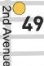

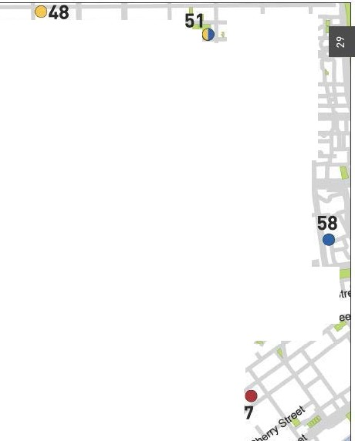
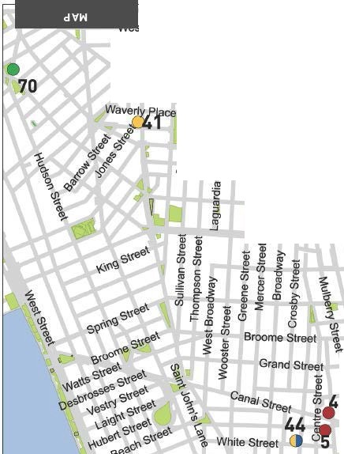
OJ

/) <t>
.,,(!.)..._
".s'- - 62 •.dl
"

OTHER ASSISTANCE
Additional organizations in your neighborhood that can as- sist you with matters other than food support.

MEDICAL CARE

Bellvue Hospital
462 1 Ave., 10016
212 562 5525
Gouverneur Hospital
227 Madison St., 10002
212 238 5110
New York Presbyterian Lower Manhattan Hospital
170 William St., 10038
212 312 5110
William F. Ryan Chelsea Clinton Community Health Center
645 10 Ave., 10019
212 265 4500
Judson Health Center
34 Spring St., 10012
212 925 5000
Roberto Clemente Health Center
540 E. 13 St., 10009
212 387 7400

HEALTH INSURANCE

Affinity Health System
Information regarding health insurance, including enrollment in Medicaid, Medicare and other plans.
General Info 866 694 9809
88 East Broadway, Unit 142, 10002

Neighborhood Guide to Food and Assistance - Lower Manhattan edition
30

Provides specific and detailed assistance regarding a wide range of legal topics, including agencies that might be able to help you find an attorney to represent you in court.
LEGAL ASSISTANCE
The City Bar Justice Hotline
212 626 7383
Mon–Thu 9am-5pm, Fri 9am-1pm
Free, basic legal advice on a range of civil issues. Will not provide an attorney or assist with in-court representation.
X
MORE HELP
EMERGENCY NUMBERS

National Hunger Hotline 866 3-HUNGRY (866 348 6479)
NYC Hunger Hotline 866 888 8777 Police, Fire or Ambulance: 911 Emergency Shelter: 311
Homeless Hotline: 800 994 6494, 212 533 5151
Immigration Hotline: 212 419 3737, 800 566 7636
Center for Disease Control: 800 232 4636
Poison Control: 800 222 1222
AIDS Hotline: 800 541 AIDS, 800 233 7432 (Spanish)
Alcoholics Anonymous: 212 647 1680
Narcotics Anonymous: 212 929 6262
Gamblers Anonymous Hotline: 855 222 5542
Domestic Violence Hotline: 800 621 4673
Battered Women Hotline: 718 499 2151
Rape & Sexual Assault Hotline: 212 423 2140, 212 227 3000
Child Abuse Hotline: 800 342 3720
Runaway Hotline: 800 786 2929 (800 RUN AWAY)
Crime Victim Hotline: 212 577 7777, 800 689 4357
Suicide Hotline: 800 273 8255
National Crisis Line: 800 999 9999

Credits: Icons adapted from The Noun Project collection. Map data © OpenStreet- Map contributors.

Neighborhood Guide to Food and Assistance - Lower Manhattan edition
31
WHAT AM I ELIG IBLE FOR ?

Use the chart below to see what programs may be available for you and your family.
e CD 0


PEOPLE WITH CHILDREN
e 0

PEOPLE WITHOUT CHILDREN
e a> 0

SENIOR CITIZENS
e CD 0

HOMELESS INDIVIDUALS

LEGAL IMMIGRANTS
e CD 0

UNDOCUMENTED IMMIGRANTS
() 0

A SNAP/ Food Stamp 0Groceries at Food Pantries WIC Packages
'1Benefits
School Breakfast & Lunch - Meals at Soup Kitchens
W Free Summer Meals for Children
/IP\ Meals at Senior Centers
\ii Home-delivered Meals
-IU:JN6ER

FREE
NYC
Have any suggestions on how to make this Guide better? Email gu ideslilhu ngerf reenyc.org.

